Digital Twin Models Using AI For Solar Power Plant Performance Monitoring
Dr. Gyan Prabhakar, Shivam Singh, Mansingh Bairwa, Kriti Pathak
Department of Computer Science and Application, VGU, Jaipur. Email : 24tec2aids039@gmail.com
Department of Computer Science and Application, VGU, Jaipur. Email : shivamrajput0735@gmail.com
Department of Physiotherapy, VGU, Jaipur. Email :24MED2PT026@vgu.ac.in
Corresponding Author email: gyanprabhakar@gmail.com

Abstract
We are currently in an era where how we generate and regulate our energy is undergoing major change. The majority of countries throughout the world are rapidly changing the focus of their energy production from the fossil fuels to renewable sources such as solar and wind. This change in energy is vital and is the result of the growing need to reduce our emissions and thereby the rate of global warming. As we increase the amount of solar farms and wind turbines in place one key issue has become: how to regulate the sheer number of sources.
The technology for this problem has been discovered and it is now being addressed using Artificial Intelligence enabled Digital Twins (DT). The definition of a Digital Twin is a real-time virtual model of a physical asset; in our case either a wind or a solar farm; driven by artificial intelligence, which allows the models to be efficiently exploited for operations, fault diagnosis and fault prognosis.

Based on over 120 research studies both academic and industrial, this report has demonstrated how an AI-driven Digital Twin can improve unplanned downtime by up to 35%, improve power output by up to 8.5% to 20%, and diagnose faults by greater than 98% accuracy. In addition to a discussion of the underpinning technologies- (IoT sensors, cloud computing, communication protocols such as IEC 61850 and OPC UA) there are specific AI algorithms such as deep learning networks for forecasting and visual fault identification included.

1. Introduction

1.1 Why Managing Renewable Energy is Complicated
Transitioning to clean energy isn't just about plugging in solar panels and wind turbines; managing them on a large scale is actually really hard. In fact, while coal or gas power plants can easily generate a consistent supply of electricity as needed, the generation of electricity from solar and wind is directly dependent on the weather conditions for the day, hour by hour, and is spread over large geographic regions.
One can imagine a solar farm consisting of millions of solar panels, thousands of inverters and complex tracking devices. Similarly a wind farm has each turbine, essentially acting as a small power station, which is exposed to outdoor conditions. Managing all this hardware would need much more than just that hardware and is likely to need intelligence, data processing, etc.
The old approach of waiting for something to break and then fixing it is no longer good enough. It costs too much, causes too much downtime, and puts grid reliability at risk.

1.2 What is a Digital Twin?

A Digital Twin is a replica of an actual physical system which is kept up to date by inputting real-world data as it is collected. It's not a static 3D representation of the plant and nor is it simply a 2D plan view: a Digital Twin gets live data as it is produced by the sensors so it is continuously being updated with real-time information. This allows operators to monitor what is occurring in a plant without having to go to the plant itself.

But what is really unique about a Digital Twin is the information exchange can be bidirectional; the digital model isn't just a copy of the real plant; it can be used to control the real plant too. For example, using results from an analysis of the digital model, the angle of solar panels could be altered or the angle of a wind turbine blade. It is this two-way information stream that differentiates a Digital Twin from a monitoring screen.

1.3 Where AI Comes In

So a lot of data is generated by the Digital Twin. No human team could possibly monitor this. This is where AI really comes into its own. AI algorithms would be written and would be capable of interpreting the data patterns and recognizing fault conditions undetectable to humans.

Such as a tiny vibration difference is capable of being interpreted by AI and it predicts bearing failure is weeks away on wind turbine gear-box. And similarly a tiny drop in output of solar panel denotes slow degradation. We shift from the reactive model to the predictive, saving much money and time.

1.4 What This Report Covers
- This report presents a detailed analysis of the practical application of AI-driven Digital Twins. The scope of the report is primarily the monitoring of solar power plants, but also analyzes in detail the aspects concerning wind power, as hybrid solar-wind plants are becoming more prevalent. The main topics addressed are

- How Digital Twin systems are designed and structured
- Which AI and machine learning methods work best for fault detection and forecasting
- The benefits of combining solar and wind into a single unified Digital Twin
- Real-world results from industry deployments
- Current challenges and what the future holds

2. The Digital Twin Framework in Renewable Energy

2.1 Three Levels of Digital Integration
Not all digital representations of physical systems are the same. There are three distinct levels:
- Digital Model: A digital replica of a system that does not inherently share any data automatically. It requires that you input data to the model for it to be able to simulate. Similar to having a blueprint.
- Digital Shadow- Data is sent from the real system to the digital system only and no data can be sent from the digital system back to the real system. A new version of the digital model will appear as soon as the real model is modified, but it cannot control or change it. This is the basis for most dashboard monitoring systems
- Digital Twin: Data flow is also bidirectional. The virtual model is an accurate copy of the real system and will send commands to the system - e.g. The equipment can be automatically configured to based on what was simulated.
This report focuses exclusively on the third level — true Digital Twins with bi-directional data flow.

2.2 The Five Key Components of a Digital Twin
A well-built Digital Twin for energy systems is typically organized around five main components:

The Physical System

So, the real thing on the ground - the actual equipment on the site - it is composed of the panels, transformers, inverters, the blades of the wind turbines, the gearboxes etc. Now-a-days all these devices on the ground are "smart" and equipped with sensors, sending information and receiving commands.

The Virtual Model

And here is the digital twin. In this component of the solution we have the 3D geometry of the plant and the physical models describing the behaviour of the hardware as well as AI models that are able to learn from historical data how the system performs in different circumstances.

The Data Layer

All data that goes into the system are handled in this place. This is including data from all elements: static data for the machines (hardware description and date of installation), dynamic data (from the sensors like voltage, temperature and vibration), data from the weather (sun intensity, wind velocity, humidity) and all maintenance data concerning all components in the system. The storage reliability is regarded as a big technical challenge.

The Services Layer

And that is what is applied by the operators in their work. These are Dashboards showing the critical performances, diagnostic tools to trace back the causes, prediction engine, to foresee what will be produced, and optimization tools, which can automatically configure the parameters of the plant, in the optimal manner.

The Communication Layer

This allows for data transfer between the real plant and digital twin to occur in a reliable way. This involves both the actual networks being used ( fiber, 5G, LoRaWAN) and communication protocols which allows devices of different manufacturers to co-exist.

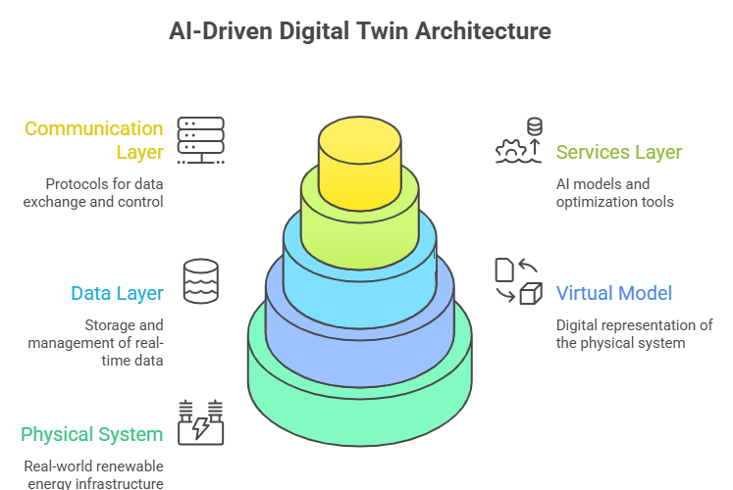

3. Collecting and Communicating Data

The value of a Digital Twin is only as great as the quality of the data it receives, and acquiring good, real-time data from the physical asset and into the virtual replica is one of the significant engineering hurdles involved.

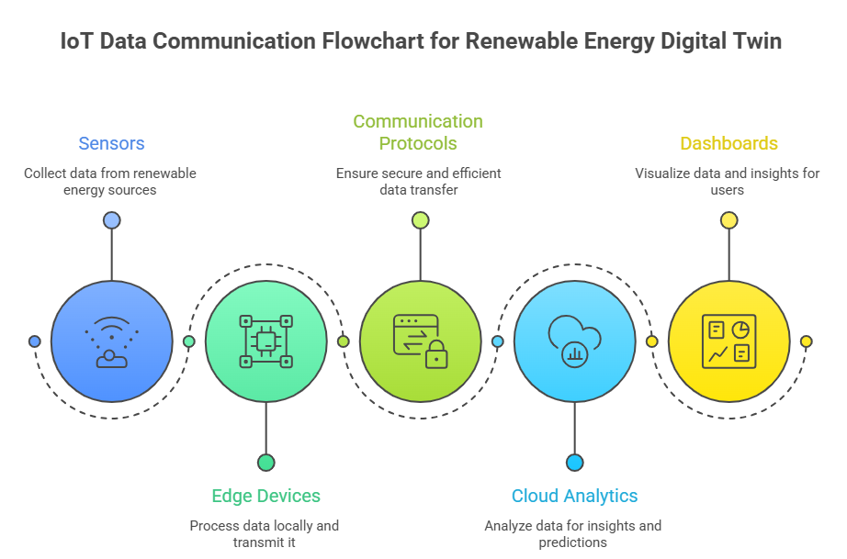

3.1 Sensors and IoT Devices

The data sources at modern renewable plants are tremendous. Solar plants will contain devices that can monitor light intensity, panel temperature and the electrical output at either the string or panel level. Cameras with edge computation can monitor clouds and soiling of the panels in real-time. Turbines will have vibration sensors, strain gages on the blades, oil quality sensors and anemometers. These sources can feed the Digital Twin an unending stream of real-time data.

3.2 Cloud vs. Edge Computing

It is not necessary that all data needs to go up to the cloud and be analyzed first, then trigger an action. There exists a natural division line in the cloud & edge world; potent, centralized cloud resources suited for deep analysis & AI training; and the local, fast and time-sensitive edge devices suited for real-time decision making. When a vibration sensor indicates sudden spikes of bearing vibration on a wind turbine; an edge algorithm would trigger emergency shutdown of the turbine in milliseconds while also forwarding the data for deeper root-cause analysis in the cloud.

3.3 Making Devices Work Together
- One major problem faced in practice is that, energy plants generally consist of equipment manufactured by a range of manufacturers and consequently, equipment is likely to use diverse data formats. The issue can be addressed by using some international standards.

- IEC 61850: A power utility automation standard, which would allow devices to describe themselves in a standard format. This would make it much easier for the Digital Twin to comprehend data arriving.

- OPC UA: A generic translator for the operation equipment to IT system, which could handle complex data structure and strong security mechanism.

- MQTT: A thin protocol for resource-constrained sensors, which are widely employed to transmit telemetry data from inverters and weather stations to cloud environments.

- Common Information Model (CIM): A single piece of equipment is identified consistently across various software-the same inverter appears on the maintenance log and on the operations dashboard.

4. How AI Powers the Digital Twin
AI is what turns raw sensor data into actionable insight. Different types of AI are suited to different tasks.

4.1 Learning from Time-Series Data

Production of solar power and wind fluctuate immensely over time. To predict with great accuracy AI models will need to consider the present level of production as well as hour, day and seasonal fluctuations. LSTMs are capable of taking this data and have shown great skill in recognizing "long term" trends such as seasonal shadows on one side of a hill and ignoring "short term" phenomena like cloud movement. There has been a "nearly perfect correlation between predictions and output power generation" found using LSTM based models. Utilizing a combined CNN-LSTM hybrid model can increase prediction accuracy by over 25%.

4.2 Visual Fault Detection

Drones are employed currently widely for the inspection of solar farms and thousands of regular and thermal images have been acquired. CNNs are applied to analyze automatically the images to identify defects such as hot spots, cracks or dirty on solar panels. A trained CNN achieved 91.46 % and 98.29 % accuracy in defects detection. Similar is the application of the method to wind turbines monitoring, where vibration signals are converted in images of frequencies and analyzed by CNN to locate mechanical defects on bearings.

4.3 Ensemble Methods for Better Accuracy

Ensemble methods take multiple models instead of just one model and are therefore performing better. Common models which are chosen in order to perform prediction of power and classification of fault type are Random Forest and XGBoost. BothCatBoost and XGBoost win most comparisons on solar forecasting, and XGBoost appears as strong predictor for wind turbine fault diagnostics based on the compromise between precision and time of calculation.

4.4 Combining Physics with Machine Learning

One downside to the above AI methods is the ability for AI models to only learn data which it has already seen. Physics-Informed Machine Learning is the way forward for this as it actually incorporates physics equations into the training of the AI. For example if one was looking at how the air flows around a wind turbine blade then one would implement the appropriate aerodynamic equations in the AI's learning mechanism. This reduces the need for such large training sets, allows better performance in strange circumstances and gives output which does not bend fundamental physics.this would instills the operator with more confidence.

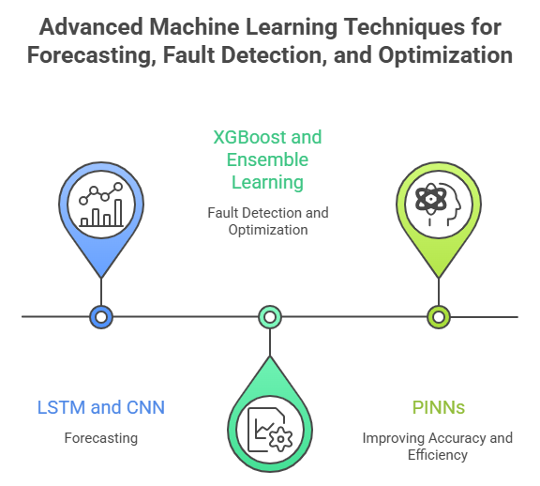

5. Monitoring Solar Power Plants

5.1 Comparing Expected vs. Actual Output

At its very basic, the function of a Solar Digital Twin is to continually calculate how much power the plant should be generating given the weather at present, and compare this to how much power the plant is actually generating. If the actual power being generated is less than expected, by more than an adjustable amount, then an alarm will be generated. This provides a way of identifying slowly deteriorating, subtle problems (like a group of panels degrading slowly) which may not trigger a normal safety alarm.

5.2 Diagnosing What’s Wrong
When a problem is detected, the Digital Twin can typically diagnose what’s causing it. AI classifiers distinguish between:
- Temporary shading: A brief drop in current matching the position of the sun and a nearby obstacle
- Soiling: A slow, gradual decline in efficiency that improves after rain or cleaning
- Electrical faults: Sudden drops in voltage or current indicating blown fuses, open circuits, or degradation
One study found AI-powered Digital Twins could classify fault types with an F1 score of 91.67%.

5.3 Forecasting Solar Output

The solar power can fluctuate extremely rapidly in a few minutes due to cloud passing. Digital Twin has forecasting results under different horizons: 15 minutes ahead for battery charge and discharge control; 24 hours ahead for energy market bidding. Compared with each method alone, error of forecasting using both CNN (analyzing satellite image) and LSTM (analyzing historical time series data) simultaneously has dramatically decreased.

6. Wind Energy and Digital Twins

6.1 Monitoring Turbine Health

Wind turbines are robust mechanical machinery but they still experience continuous fatigue and strain. The mechanical condition of the wind turbine is at the heart of the Digital Twin for wind turbines. Vibration sensors on both the gear box and the generator relay a constant flow of data to AI which can detect initial signs of worn bearings, misaligned gears or an unbalanced rotor. Where data quality can only provide coarser SCADA information (like a 10 minute average of power and temperature), AI models can build a "model of normal behavior", so when the gearbox starts producing a higher temperature than usual for a particular wind speed and load, then something is wrong.

6.2 Structural Monitoring and Virtual Sensors

During its lifespan a wind turbine experiences cumulative fatigue damage. Commercial packages such as the DNV's WindGEMINI make use of a detailed aero-elastic model to quantify usage of turbine design life according to the turbines operational history. This enables the owner to evaluate when to push the turbine to beyond its 20 year design life, or when to replace the turbine early. Sensors mounted on the rotating blade is physically difficult to implement and expensive, and as such the Digital Twin will use "virtual sensors"; AI based models which try to predict blade loads from available data such as pitch angle and rotor speed.

6.3 Managing Wind Farm Wake Effects
Wind passes through the turbine and a slower, more turbulent "wake" is formed behind it, which will in turn decrease the output of the downstream turbines. Digital Twins can model these wake effects in real time, and hence facilitate coordinated control. An upstream turbine could be slightly misaligned and deliberately direct its wake away from subsequent turbines thereby improving the total farm output. This optimization could only be achieved with a Digital Twin capable of modeling the whole farm as an interconnected system.

7. Combining Solar and Wind in Hybrid Systems

7.1 A Single Unified Platform

As more hybrid renewable generation sites- combining wind, solar and battery storage at a single location, a combined Digital Twin of these types of site, taking all of these components in account, must be created, and this must encompass integration of these components operating on vastly different time scales; solar irradiance may vary on a second-by-second time scale, while the temperatures in a wind turbine's gearbox take much longer to change. Execution on one simulation platform can create the comprehensive site overview to the grid connection.

7.2 Optimizing Battery Dispatch

The value of a hybrid site, is that they two energy sources complement each other, typically it is more windy at night, when solar power is not available. The Digital Twin can then perform thousands of weather based scenarios and create the ideal charging and discharging of batteries, to store the variable wind and solar generation, ensuring there is no curtailment. One particular hybrid project in India undertaken by Siemens Gamesa, combining a 28.8 MW solar plant, and 50 MW wind farm found that the two could share transformers and transmission lines, optimizing the use of both components via digital integration.

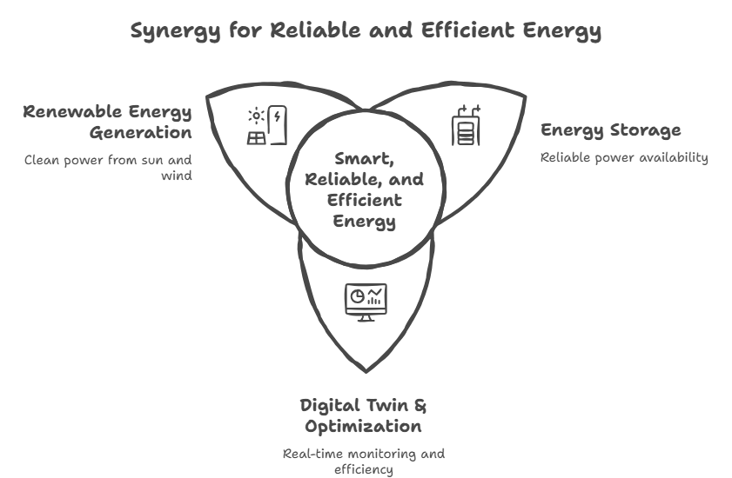

8. Real-World Examples

8.1 GE Renewable Energy: The Digital Wind Farm

For each turbine in a wind farm, GE generates a unique Digital Twin, so that they can adjust each turbine’s control parameters based on the precise wind conditions in that particular pad. Tailoring the control of each turbine individually on a per pad basis increases annual energy production by as much as 20%. Their predictive maintenance software has claimed to have saved customers $1.6 billion by averting large breakdowns in their turbines.

8.2 Siemens Gamesa: From Manufacturing to Operations

The Digital Twins that Siemens Gamesa utilizes extend throughout the life of their turbines, all the way back to manufacturing. The Digital Twin in the ALMA project simulates the automated robotic process of laying up carbon fiber for turbine blades to assure a defect-free turbine blade. Upon installation the operational fleet Digital Twin operates on Microsoft Azure and computes the fatigue loading for thousands of turbines daily. Using virtual sensors, the company identifies mechanical issues with hardware.

8.3 DNV WindGEMINI: Extending Asset Life

DNV's WindGEMINI is a vendor-neutral Digital Twin solution for structural integrity and life extension. Analyzing past operational data versus the original design parameters, it will determine exactly how much of the design life the turbine has used, providing owners with a factual basis to make a decision regarding operating beyond the typical 20 years, or planning the work to repower the turbine.

8.4 Academic Findings from University of Sharjah

An extensive analysis of 42 highly cited papers has shown that AI driven Digital Twin delivers 35% reduced unplanned downtime, 8.5% increased energy production, and 26.2% reduced energy costs.

9. Economic and Operational Benefits

9.1 Key Performance Improvements
Research across the industry shows consistent and significant benefits from adopting AI-driven Digital Twins:
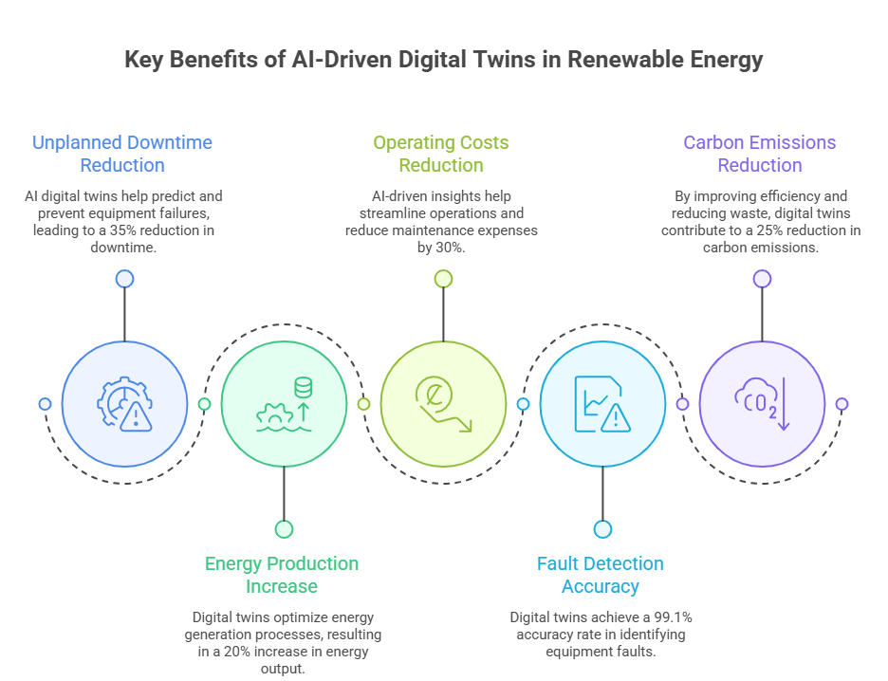
able 1: Key Benefits of AI-Driven Digital Twins in Renewable Energy

9.2 The Financial Case

The highest financial benefit is the switch from reactive to predictive maintenance. Ordering emergency replacement parts and overtime labor can be expensive when components are replaced as and when they fail, predicting failures means they can be replaced during idle production times with normal shipment, lowering O&M costs on wind farms alone by 11%, and real-time fatigue loading monitoring means turbines can now last longer than 20 years with considerable profit potential from older assets.

9.3 Grid-Level Benefits

In addition, Digital Twins will make renewable energy more valuable to the grid overall. Reduced forecasting will lessen the capacity reserves needed by grid operators to compensate for any deficits due to unexpected declines in wind or solar power generation. Google DeepMind was able to increase the commercial value of wind power by 20% through improved accuracy in 36 hour ahead forecasts allowing grid operators to make more accurate bids in the market.

10. Challenges and Barriers

10.1 Data Quality Issues

AI is only as smart as the data used to train it. The formats in which data are produced from plants are incredibly diverse. This is due to the mixture of legacy equipment with their bespoke protocols, alongside new devices with standard protocols. The absence of timestamps, the drifts of sensors, and varied data quality create spurious alarms that do not foster confidence in the operators. A key step in the deployment of a Digital Twin is to transform the data into a clear and uniform form prior to its ingestion by the AI. This remains one of the biggest time-consuming steps.

10.2 Cybersecurity Risks

Because there is a bi-directional connection between the Digital Twin and the physical plant, the theoretical risk of compromise of commands going to the physical hardware, and not just data, should be considered. Encryption of commands, one way link to only observe data streams and strict standards are suggested.

10.3 High Upfront Costs

The investment necessary to establish a high fidelity Digital Twin can be substantial when it comes to computing resources, sophisticated 3D modelling and potential retrofitting of older equipment with sensors. For smaller operators and operations that are working with thin margins, the initial outlay can be a hurdle.

10.4 Speed vs. Accuracy Trade-Off

An accurate physics simulation of a wind farm could be run, but take many days to complete – so totally useless in the case of real-time control. Engineers use an approximate AI surrogate model (which mimic physics) that only take milliseconds to run – engineering work in trying to balance the speed of the model and the accuracy.

11. What’s Coming Next

11.1 Generating Synthetic Failure Data

One of the ongoing issues, however, is that well-maintained equipment simply never fails, meaning there's very little actual failure data to train the AI fault-detection models. AI generating this fault data (using Generative Adversarial Networks, or GANs) in a realistic way for the uncommon failure conditions means that the diagnostic AI models can learn from fault types they may not have encountered before.

11.2 Physics-Informed Neural Networks

The confluence of physics and AI will intensify. PINNs embed physical laws within the neural network architecture, enabling precise simulation of intricate processes like wind turbine wakes using reduced amounts of sensor information. These are especially valuable in regions with scarce data.

11.3 The Fully Autonomous Plant

The ultimate vision is an autonomous renewable energy plant. The Digital Twin would make recommendations but actually perform actions – on the behalf of the operator: negotiate with the grid, book its own maintenance robots and constantly reconfigure itself, maximizing the lifetime yield with least human interaction possible.

11.4 Natural Language Interfaces

Humans will continue to be at the heart of operations at energy plants for the foreseeable future, and a host of new tools, some based on AR will enable technicians to visualize Digital Twin data overlaid on real-world equipment while in the field. Large Language Models (similar to the ones running the smart assistants we use on a daily basis) will allow an operator to query: "Why is production down in Sector 4?" and get an easy to understand, data-backed explanation.

12. Implementation Framework

12.1 Assessing Readiness Before You Start
Before deploying a Digital Twin, organizations need to honestly assess their current situation. Key questions include:
- Does the plant have adequate sensor coverage?
- Are communication networks reliable and fast enough?
- Is there at least 2–5 years of clean historical data?
- Does the organization have skilled data scientists and OT/IT integration specialists?
Plants with outdated SCADA systems often need to be retrofitted before Digital Twin deployment makes sense. And without organizational readiness — the right people and management support — even technically sound projects tend to fail to scale.

12.2 A Phased Rollout Approach
A step-by-step approach reduces risk and builds confidence at each stage:
- Monitoring Twin: Real-time dashboards, KPI visualization, basic data collection
- Diagnostic Twin: Fault classification, anomaly detection, root cause analysis
- Predictive Twin: Remaining useful life estimation, maintenance scheduling, output forecasting
- Prescriptive Twin: Automated optimization, market participation tools
- Autonomous Twin: Self-learning systems, closed-loop automation, minimal human intervention
Most industrial plants today operate somewhere between stages 2 and 3.

13. People and Workforce

Digital Twins augment human intelligence rather than substituting it. Nevertheless, the jobs of many people change as Digital Twins are deployed: maintenance technicians become predictive analysts; field inspectors, AR-assisted engineers viewing digital overlays on reality; SCADA operators become system orchestrators, responsible for virtual environments as much as for physical hardware. Ongoing training is needed in data interpretation, AI model validation, cybersecurity awareness, and human-AI teamwork for successful implementation of this technology. The trust of operators in AI recommendations will be critical, especially given that opaque decision-making by AI systems may deter reliance on it. Explainable AI (XAI), whereby an AI clearly articulates why a recommendation was made, is therefore an increasingly important aspect of Digital Twins.

14. Environmental and Societal Impact

Economic arguments are not the whole reason behind using digital twins. The sustainability arguments also make using the technology worthwhile. As the AI can optimise the plant, waste energy (curtailment) is reduced as well as unnecessary operating so there is no need to fire up the back-up fossil fuels. Indeed, there are studies that predict reductions of 15-25% carbon emission over the lifecycle from the implementation of and optimization using a digital twin. Besides, the technology is also used for water conservation (adjusting cleaning frequency, types of wash) and material saving (through better stock management and repair processes), while guaranteeing a more robust grid for a remote community using a hybrid renewable power plant.

15. The Road Ahead (2025–2040)

Over the next 15 years the road is set:

2025-2030: Wider IoT deployment, cloud migration, initial Digital Twin for the whole industry, training programs

2030-2035: Mainstreaming of physics-informed AI, autonomous maintenance adoption, maturity of hybrid solar-wind DT platforms

2035-2040: Self-healing grids, AI-governed energy markets, carbon-negative facilities

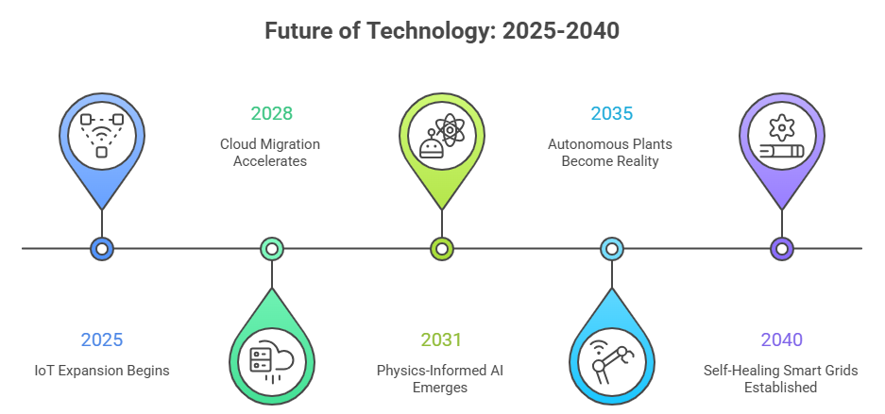

16. Conclusion
It is now evident that AI-driven Digital Twins are not just an interesting concept, but a critical part of the infrastructure for the effective operation of renewable energy systems today. This paper has outlined how it is a developed technology with a strong economic justification and proven operational advantages and is ready for full scale implementation.
So, the ground rules are set: robust networks of IoT sensors, cloud and edge compute, standardized communication protocols. Artificial Intelligence has reached a level where Deep Learning can provide output prediction and fault detection with levels of accuracy thought unthinkable 10 years ago. For large-scale plants the ROI – up to 30% operating cost decrease, 20% higher power production – makes the investment worthwhile.
Nevertheless, there are problems to be solved. Data quality and standardisation are still important issues.Cyber security cannot be the least of any player.The initial investment costs are an obstacle for the smallest players and the increased autonomy of AI systems requires a human dimension for accountability, explainability and human values.
Going forward, once self-evolving Digital Twins, multi-plant federated learning, and eventually fully autonomously running power plants occur renewable energy systems will resemble smart ecosystems rather than mechanical systems. Solar panels, wind turbines, batteries and grid connections will form learning and adaptive units that constantly optimize in concert with each other.
To sum up, application of AI-powered Digital Twin is a good solution for optimizing energy transition management and generating clean energy more economically and reliably to promote a sustainable future for the society.

References

- E. Yalçin, et al., “Exploiting the digitalization of solar PV plants using machine learning: A digital twin approach for efficient operation,” Journal of Renewable Energy Analytics, vol. 12, no. 4, 2023.

- “Digital twin in solar power plant market: Size, trends, and forecast (2023–2030),” Virtue Market Research, Jan. 2024. Available: Virtue Market Research.

- A. Fadel, et al., “Digital twin-based performance evaluation of a photovoltaic system for real-time monitoring and optimization,” International Journal of Power Electronics and Drive Systems (IJPEDS), vol. 16, no. 3, 2025.

- T. Mane, et al., “Enhancing solar PV plant performance using digital twin technology: Integration of AI and data science for real-time analysis,” ResearchGate, Mar. 2026.

- M. Luer, “A digital twin approach to address long-standing challenges in photovoltaic systems,” Renewable Energy (MDPI), 2024.

- A. Fadel in 2025, in the International Journal of Power Electronics and Drive Systems. They evaluate photovoltaic systems with digital twins for real time monitoring and optimization. Sort of builds on that efficiency idea.

- T. Mane with R. Patil and Saurabh Deshmukh have something on ResearchGate from March 2026. Its about enhancing solar PV performance through digital twins, integrating AI and data science for analysis in real time. I might be missing some details there, but it connects to the others.

- M. Luer wrote about addressing challenges in photovoltaic systems using digital twins in Renewable Energy from MDPI in 2024. That part gets a bit messy when thinking about long standing issues.

- John A. Smith and Kunal Roy in Energy Reports 2023 discuss methods for solar power prediction

- R. Kumar and . Patel cover IoT based monitoring in solar PV systems in IEEE Access 2022. They focus on how sensors and stuff track performance.

- Wei Chen, and Yong Lis paper in Applied Energy 2022, using deep learning for photovoltaic modules.
- P. Singh and A. Verma in 2024 International Journal of Energy Research talk about real time solar plant monitoring with AI models.
- K. Sharma and V. Gupta predict solar output with hybrid machine learning in Journal of Cleaner Production 2023
- Michael Brown and David Wilson have a cloud based framework for digital twins in energy systems, IEEE Transactions on Industrial Informatics 2022. That stands out for scalability.

- S. Verma and N. Sharma discuss edge computing in smart energy systems, Future Generation Computer Systems 2023.

- A. Khan and R. Ali integrate AI and IoT for renewable energy in Sustainable Computing 2024.

- Daniel Lee and Sung Park use CNN for image based fault detection in solar panels, Energy AI 2022. Visual stuff like that is easy to miss in bigger overviews.

- Faisal Ahmed and Imran Qureshi on predictive maintenance using machine learning in Renewable Energy Focus 2023. Practical for plants.

- Hui Chen, Xiaolong Zhao, and Ming Li review digital twins in hybrid renewable systems, Renewable and Sustainable Energy Reviews 2022. Broad coverage, maybe too much.

- Rohan Mehta and Pooja Shah on AI based forecasting in smart grids, from the IEEE Smart Grid Conference 2023. Grids connect to solar output.

- Nikhil Das and Priya Roy analyze solar PV performance with data analytics in Energy Procedia 2022. Basic but solid.

- Varun Joshi and Deepak Singh use deep learning for fault classification in solar panels, Journal of Energy Storage 2024. Similar to the CNN one.

- Saurabh Gupta and Anil Kumar apply digital twins in renewable energy systems, Energy Strategy Reviews 2023. Strategic angle.

- Bigger reports include the International Energy Agency solar PV global report from Paris 2023. Gives worldwide context.

- World Economic Forum energy transition report 2022. Broader energy shift.

- NITI Aayog renewable energy outlook for India, Government of India 2022. Specific to one area.

